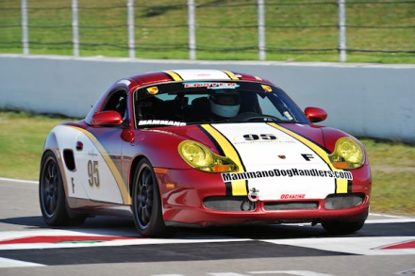

CAR CAN BE SEEN :

WATKINS GLEN OCT 3-4
Class Winning car @ Mosport , Mid OH, Multiple Podiums.
Winner of Back to Back “Best Prepared Porsche Race Car “ Award.
Purchased from Speedsport Tuning, maintained by Eksten Autoworks. & BERG Racing
IMS Bearing Updated, L&N 2 QT Deep Sump w X51 Baffle & SS Guard Plate
PSM Traction control removed to eliminate Boxster “Ice Pedal “
JRZ RS Pro remote canister double adjustable shox
TPC Adjustable sway bars Front & Rear GT3 LCAs
Fabspeed Header & exhaust
OS Giken rear Diff, .Rebuilt 12/15
Diff & trans cooler
Full Custom Cage, Fire Suppression System
Center radiator kit & Power Steering cooler
Cool Suit system
OMP halo Drivers seat – Schroth belts , Passenger Sparco halo seat w Safecraft belts
Numeric Shiter And Cables , Tarett Risers, Rennline Pedals
Window & Center Nets
OZ RACING Wheels 18 “
Functioning heater & windshield Defroster
Have Dyno Sheets & all maintenance records including Blackstone Oil Analysis sheets for Trans.
Meticulously Maintained , Completely Sorted & Extremely Reliable. Ready to Race ( current PCA Logbook), or Super DE Track Car.
Fresh Corner Balance & Alignment
SAM MAMMANO 585 727 1912 smammano@rochester.rr.com

