I had some fun with it, so far, and just thought I’d share.
While casually looking for a trailer I came across this. Well used but it seemed sound.
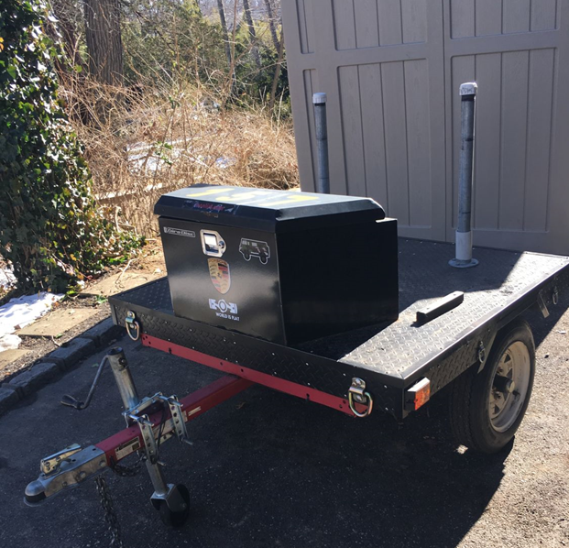

During the drive home, the lights didn’t work. I found copper cladded wire that had corroded at each tap where it was literally hanging-on by a thread. Bought a new harness, soldered and wrapped all connections and covered with loom all around to keep them clean.
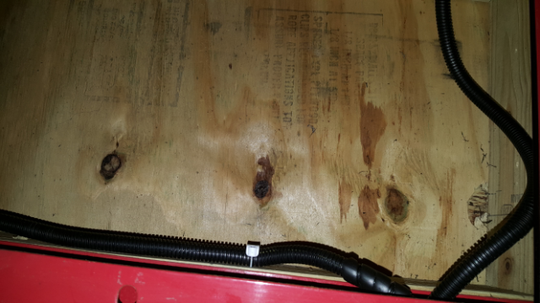

Second issue was some rusted frame supports holding the tongue to the frame. Some sand blasting, primer and paint and it was ready to go.
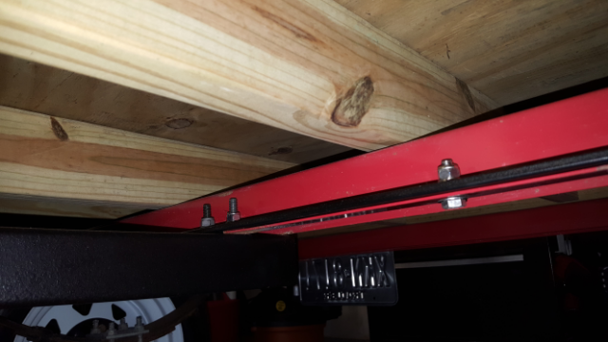

Repaint the Tongue, for kicks.
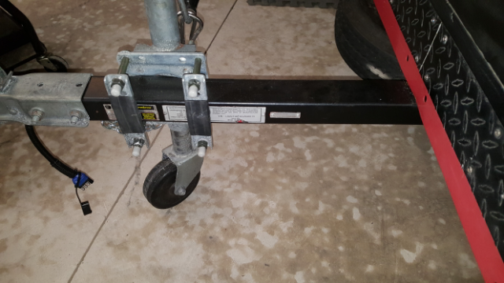
Harness enters the back of the tongue, so the plug end comes out or retracts without ever hanging down due to some foam pipe insulation controlling movement.

The included B series tires were rated at 55 mph. Very little weight on them & probably would be fine but I needed a spare so on go two C series wheels and tires rated at 80 mph.
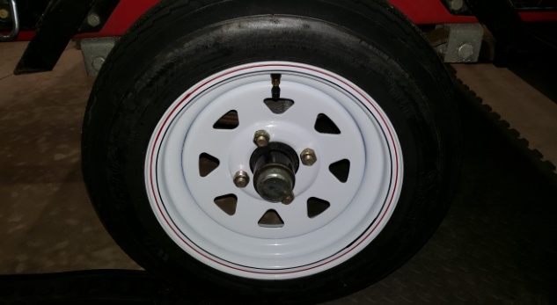

Now I have two spares. Not enough room to mount one on the tongue so I mock up a bracket and head to the plasma cutter. A tire mount that fits under the frame but still easy to get to.
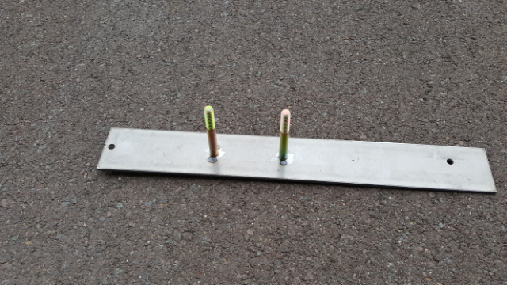
Cleaned up and painted
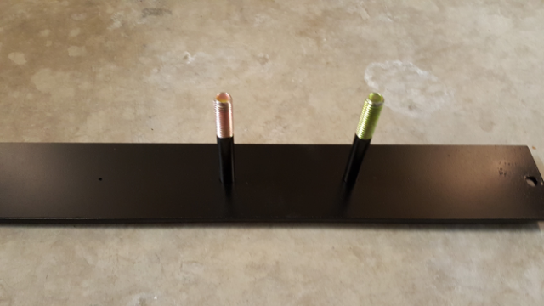

Mounted under the trailer, easy access.
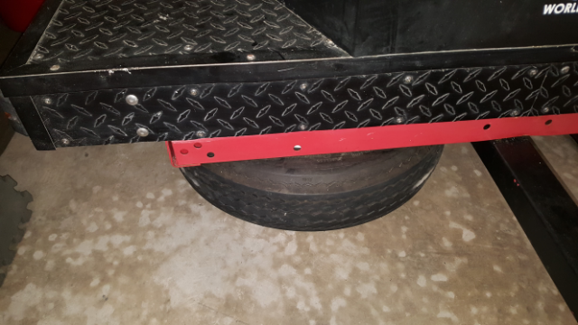

It came with a makeshift hitch. Just a 1 7/8 ball welded to the end of the factory tow eye.
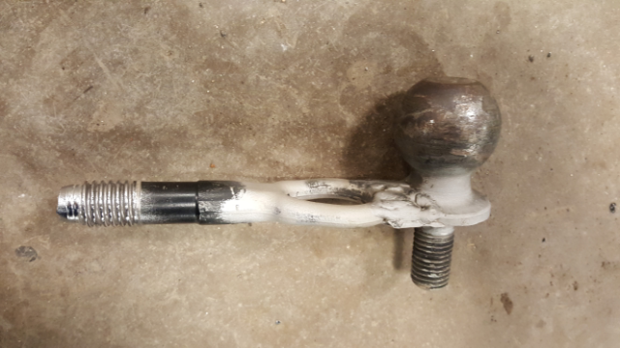
Previous owner used without issue, but I just wasn’t fond of it. Too easy to fail IMHO. Back to the Plasma cutter to mock-up a piece that goes over the threads & traces out the screw eye. Adds significant strength where the steel itself would have to fail, not just the weld.
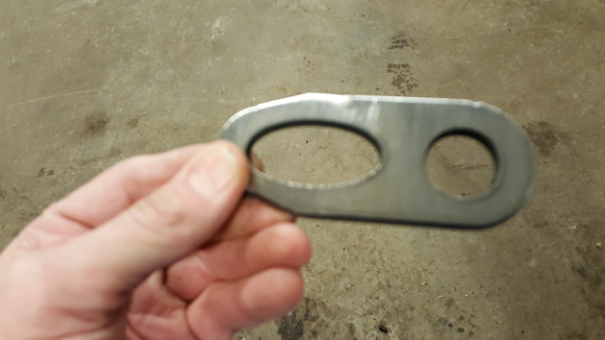

Welding it up, not much to look at yet.
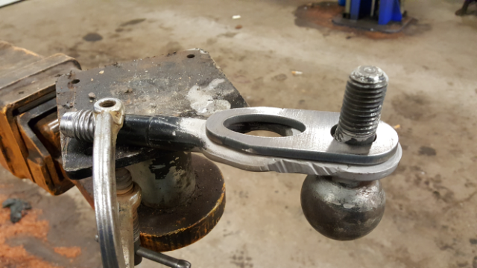
Grind off the excess & threads & clean it up a bit.
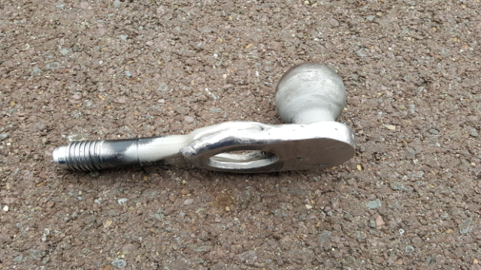

Painted up
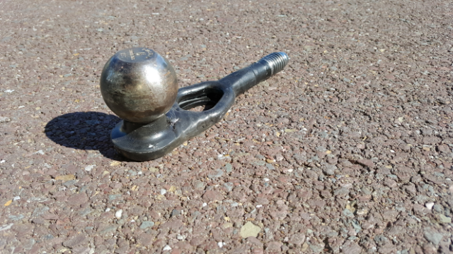

The tire posts worked fine but bare metal might scratch up those wheel centers. Can’t cover with PVC, it’s the wrong diameter and the wall is too thick for wheel centers. Hmmmm… Central home vac line is thin walled, but it won’t fit over the pipe…So a quick slit down the side to open it up a bit and viola ! For $3 I have new tire posts that won’t scratch and are durable.
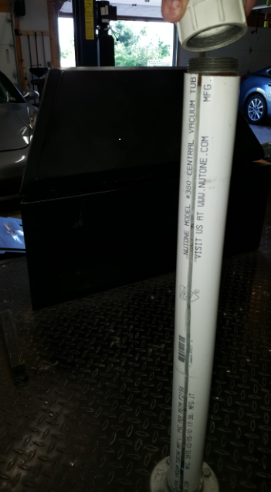
New SS screws and D-rings and it’s all done.

I did take off the bumper and mounts and had a trusted chassis builder inspect them and he felt the welds & material were capable.

Oh, the harness controller in the car went in the rear left corner. Easy to wire up using a fused 12ga wire off the battery and encased it in leftover heat protective loom. Previously had a 951 so I had all sorts of this stuff left over.

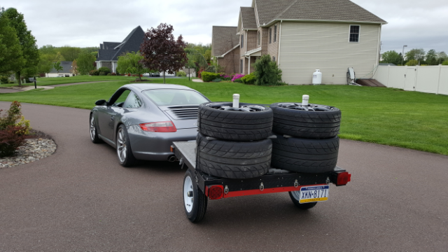

Hope you find something fun to work on!

