Technical Report for Automotive Structural Failure

Written by:

Global Technology Experts

Dr. Ash Thakker, Ph.D., P.E., FASM, FSME, CMfgE
Mr. George Kremer, ME

2839 Paces Ferry Road
Overlook II Suite 1160
Atlanta, GA 30339
Phone: (770) 803-3001
Fax: (770) 303-3017



January 2, 2012

1.0 General Discussion:

GTE was retained by Ms. Lisa Moore (owner) to inspect a 2012 Porsche Panamera (VIN number WP0AD2A71CL045354) that was significantly damaged while being towed onto a flatbed truck. A summary of the accident from supplied information is as follows:

The car’s frame fractured and the car broke in two parts during proper loading of the vehicle via the tow hook onto a roll back car carrier. One section from the frame’s front cross member stayed on the carrier. The rest of the car rolled uncontrolled, downhill on the street for about 200 feet and then into a ditch. A Porsche dealer was picking up the car for service. The owner had stopped driving the car after being unable to control its’ steering on I-20 for several brief periods. The frame’s welds may have been cracked at that time, possibly affecting the EPS and its’ integrated systems. Excessive tire wear was found on 9/11/12. Poor handling and extreme steering difficulties that reduced gas mileage about 25% began shortly after and seriously injured the owner. Four alignments were required between 9/13/12 and 10/5/12.

On 10/16/12, Porsche Cars North America (PCNA) inspected the car and identified defective welds between the ends of the aluminum frame rails and the front cross member of the frame. Both the driver and passenger side welds were defective at these points. Photos taken on 10/11/12 appear to show the welds had been cracked long enough for the exposed metal to oxidize and be virtually distinct from the brighter, freshly broken portion of the welds.
Relevant Car History:
While in Jim Ellis Porches’ (JEP) control, the car’s front bumper (driver’s side) was damaged. The damage was stated to be from “rubbing a curb”. After repair, JEP sold it as a CPO demo vehicle in June, 2012.
Porsche of Huntsville did the 2nd and 3rd alignments. Another Porsche dealer, during the 4th alignment, then found both tie rod jam nuts fully unsecured.

2.0 Opinions:

Following our review of the photographs furnished by Ms. Lisa Moore as well as inspection of the failed structure of Porsche Panamera(inspection date Dec 06, 2012) and other referenced information, our opinions are as follows:
- The subject welds appear to be original work performed by the vehicle’s manufacturer. There were no signs/indications of re-welding on the frame.

- During front-end towing high multidirectional forces exist in the towing lug and the frame. The design of the Porsche Panamera allows for front end towing. A depiction from the owner’s manual can be seen below:

However, inspection of the tow plate indicated that the tow plate welds did not distort or fracture. It is our opinion that the complex state of stress involved in towing were transmitted to the compromised frame rails, which did fracture, causing the bumper assembly (and related front-end components) to catastrophically fail. Therefore, the weakest points in the system were the frame rail welds. A photograph showing that the weld holding towing plate was intact and did not sustain any damage can be seen below:

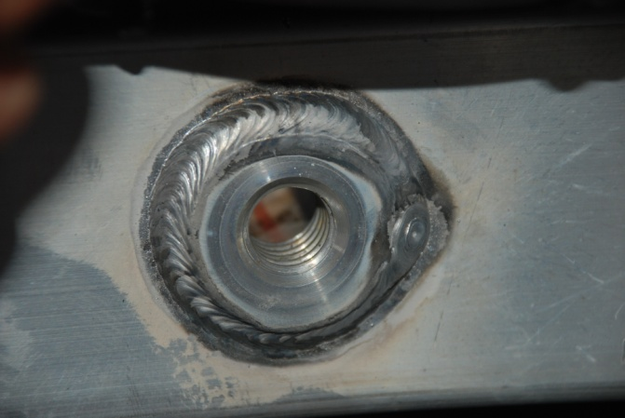

- From the supplied information, the welding process employed to join the bumper assembly flange to the frame rails is not known. However there are three ways that automobile companies routinely weld aluminum. The common methods are: Gas Tungsten Arc welding [Ref. 1], Laser welding [Ref. 2] and Delta Spot welding [Ref. 3] used in the Porsche Panamera. In aluminum welding of automotive components, base metal cleanliness is extremely essential. Base metal contamination was observed at the welded surface, as seen in the photograph below. Contamination affects the weld quality by reducing the strength of the weld. It causes incomplete or lack of fusion as impurities react with air to form oxides within the weld. The photograph below shows an example where the right frame rail appears to be painted adjacent to the weld.

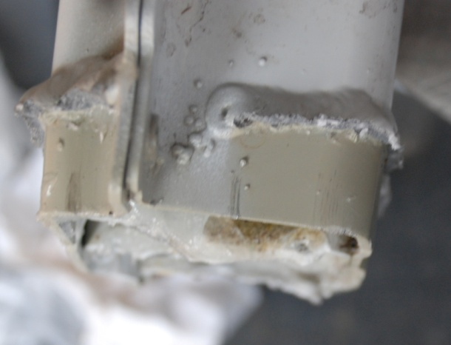

- It appears that the welding and quality control standards were not maintained in the manufacturing of Panamera 2012 S Hybrid. The standards applicable to aluminum welding can be found in [ref. 5]. The base metal surface preparation deficiencies should be typically identified earlier in automotive manufacturer’s aluminum welding quality control procedures. It is evident from inspection of a newer Porsche Panamera (loaner 2013 base model) that the weld quality seems to be much better. It appears that they might have improved the welding process as well as inspection protocol prior to the 2013 Panamera being manufactured.

- The left frame rail was observed to be bent. This can be seen in the paragraph below. It is our opinion that the frame rail was not dimensionally straight during assembly and was not checked during quality control inspection. This could account for the fact that the vehicle was unsuccessfully aligned four times by Porsche dealerships. Wheel alignment affects the handling of the car, significantly reducing tire life and adversely affecting gas mileage. Vehicles that cannot be properly aligned to the manufacture’s standards will be a hazard to drive as the operator may experience “over-steering” affects or hard steering. Technical information regarding vehicle alignment can be found in [Ref. 4] and research related to frame damage can be found in [Ref. 6].

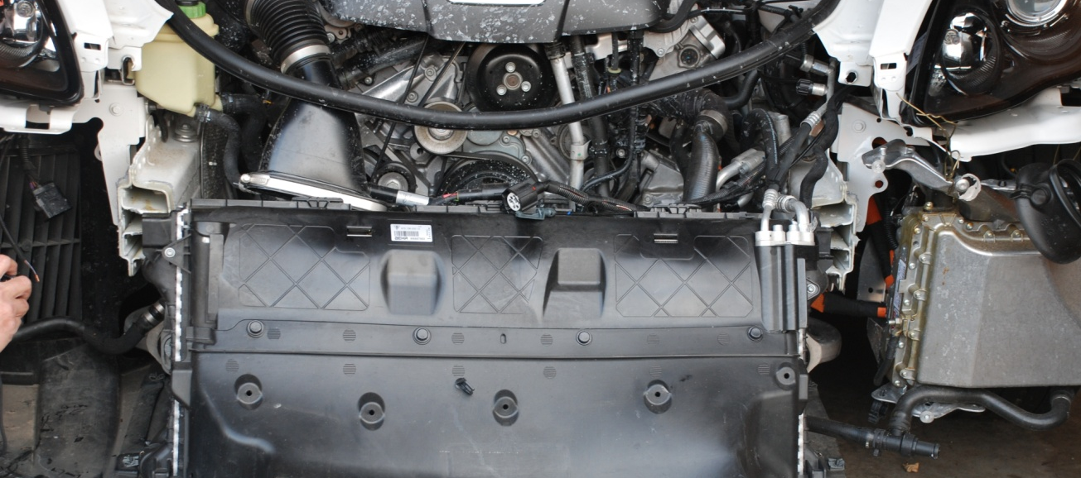
- Based on the photograph provided showing strike marks on the driver’s side of the bumper and visual inspection of the vehicle, it is our opinion that damage to the vehicle’s front bumper, while in Jim Ellis Porsche’s control, could have contributed to the failure of the welds. But, just as importantly, the very same accident can result in what is called indirect damage to the frame and body, which appears away from the area of impact. In order to assess the condition of a frame's indirect damage, it is recommended that the frame be inspected using computerized laser measuring systems.

- There is some evidence of replacement of front bumper skin as was observed in the inspection that the reflectors on the front bumper have been painted over. However, we did not observe any repair in the front structural components of the vehicle.
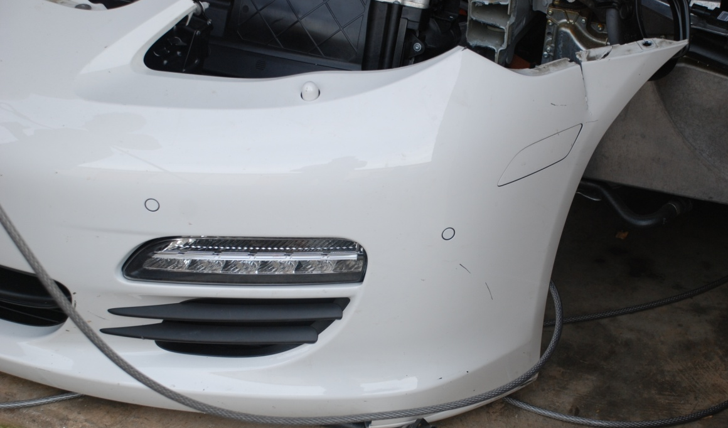

3.0 Observations:

Following an inspection of the vehicle on December 6th 2012, at a storage facility located in Alpharetta GA, our observations are as follows:

- The front end of the car separated from the remainder of the car at the right and left horizontal frame rails. This can be observed in the photo below:

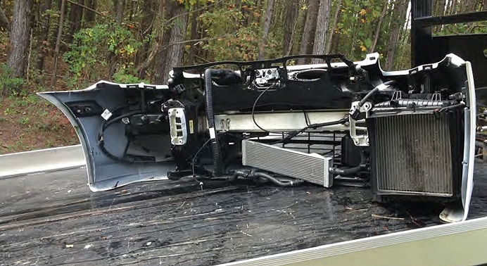

- In was observed that separation (on both sides) occurred in the area where the bumper assembly mounting flange is welded to the horizontal frame member. The failed right side rail can be observed in the photograph below:

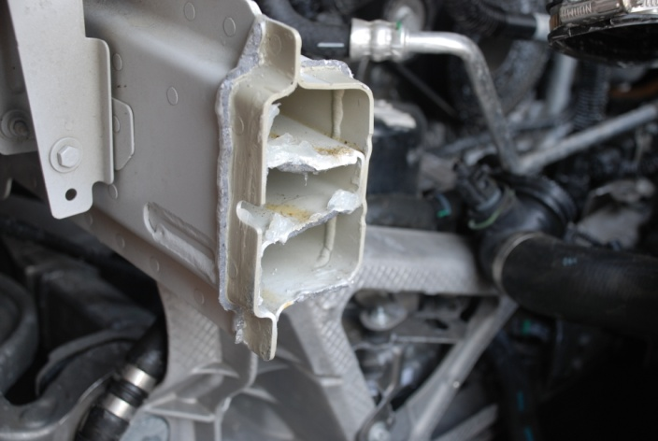

- It was observed that the welds failed in a brittle manner, exhibited porosity and had insufficient weld build-up. This can be seen (for the left-side weld) in the photo below:

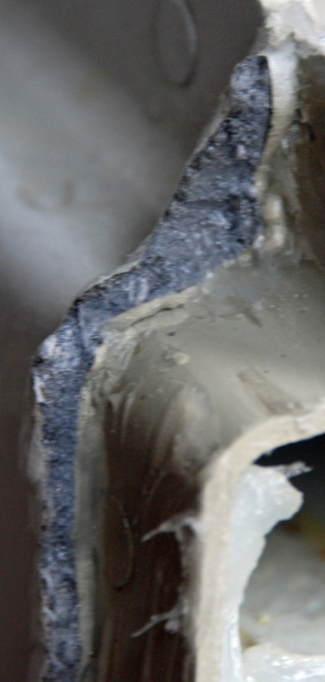

(Note that a petroleum based product was applied to the failed weld surfaces to prevent surface oxidation)

- It was observed that the right (passenger side) horizontal frame rail was bent. This can be observed in the photo below:

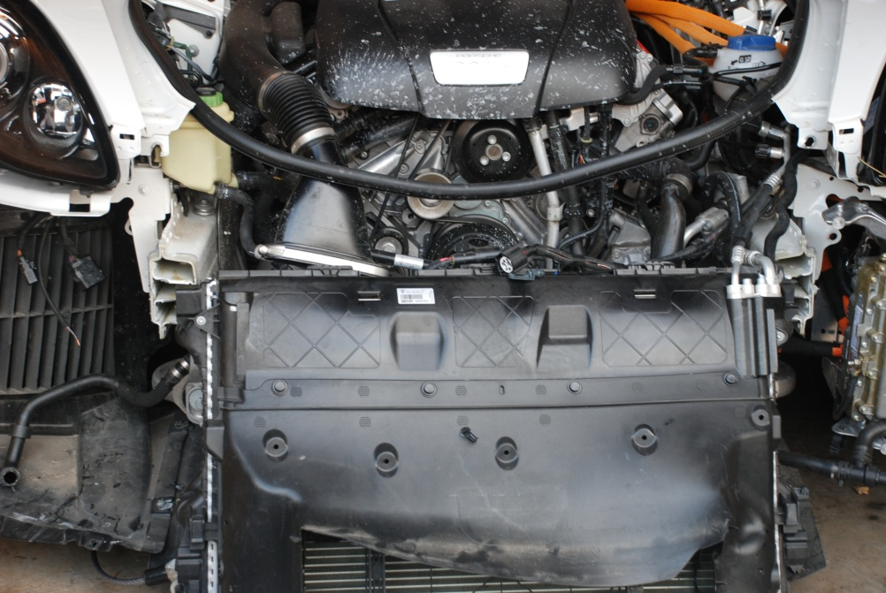

- After further investigation the bumper flange components that were welded to the frame rails were done so by a laser welding process [Ref. 1]. In order to salvage the vehicle to the point of drivability the restoration process would be to: remove the engine to expose the rails and remove the rails from the unibody frame. Note that the rails are riveted to the frame by self-piercing rivets and bonded to the frame. Once removed the rails would have to be checked for straightness and dimensional accuracy. If the damaged rails cannot be reinstalled then rails from a salvage yard would have to be used. Salvaged bumper flanges would have to be gas metal arc welded to the rail ends. With the refurbished rails in place the engine would be installed, the bumper assembly would be reattached, the vehicle aligned (using new components), the front-end breaks totally replaced, new wheels and tires mounted and the EPS (Electronic Power Steering) system recalibrated. Finally upon completion of the repairs more than likely the collision shop or dealership would have the vehicle’s owner sign a liability waver stating that the owner accepts full liability in the event of any subsequent damage.

4.0 References:

- Laser welding of structural aluminum:

http://www.youtube.com/watch?v=I2chJOwvSI4

http://laserdeposition.net/index1.html

- Gas Tungsten Arc welding:

http://www.youtube.com/watch?v=I2chJOwvSI4

- Delta Spot welding used by Porsche:

http://www.fabricatingandmetalworking.com/2012/05/resistance-spot-welding-of-aluminium-moves-to-production-line/

- Consequences of improper alignment:

Affects Vehicle Handling
Wheel alignment is a critical component of a cars handling capabilities. Wheel alignment refers to the angles and positions of the car tires in relation to the ground. A car that has proper wheel alignment will drive much easier. The wheels will be angled and positioned in a straight-ahead manner enabling a car to be driven in a straight line much easier.

Wheel Alignment Influences Tire Wear
Tires are an important part of a car. A car's wheel alignment directly influences the longevity and functionality of a car's tires. Improperly aligned wheels put extra stress on a car’s tires and greatly increase the rate at which tire tread wears out. A misaligned wheel strikes the ground at an abnormal and wear-inducing angle. Proper wheel alignment is necessary to ensure the longevity of a car's tires.

Wheel Alignment Affects Gas Mileage
As a car is driven along the highway, the contact between the pavement and the car tires produces friction. This friction is constantly putting a strain on the car's engine. A car with improperly aligned wheels experiences increased friction between the roadway surface and its tires due to the angles and positions of the misaligned tires. Tires that are not pointing straight but either slightly inward or slightly outward cause extra friction. This extra friction negatively impacts a car's gas mileage.
http://www.ehow.com/how-does_4603118_wheel-alignment-affect-vehicle.html
- Specifications and standards applicable to aluminum welding can be found here:
http://global.ihs.com/news/auto/april03_4.html
- http://framefacts.com/LearnMore.aspx

Written by:

George Kremer, ME

Approved:


Dr. Ash Thakker, PE
Global Technology Experts
2839 Paces Ferry Rd., Suite 1160
Atlanta, GA 30339

