Porsche M96 / M97 Engine Sensor Locations

Ambient Air Temp Sensor - The ambient air temperature sensor measures the air temperature in the engine compartment. This tells the DME computer how hot it is inside the engine compartment, so that the engine compartment fan can be turned on or off. This sensor is simply held in place by a rubber grommet that is attached to the intake manifold on the left side of the engine near the air-oil separator.
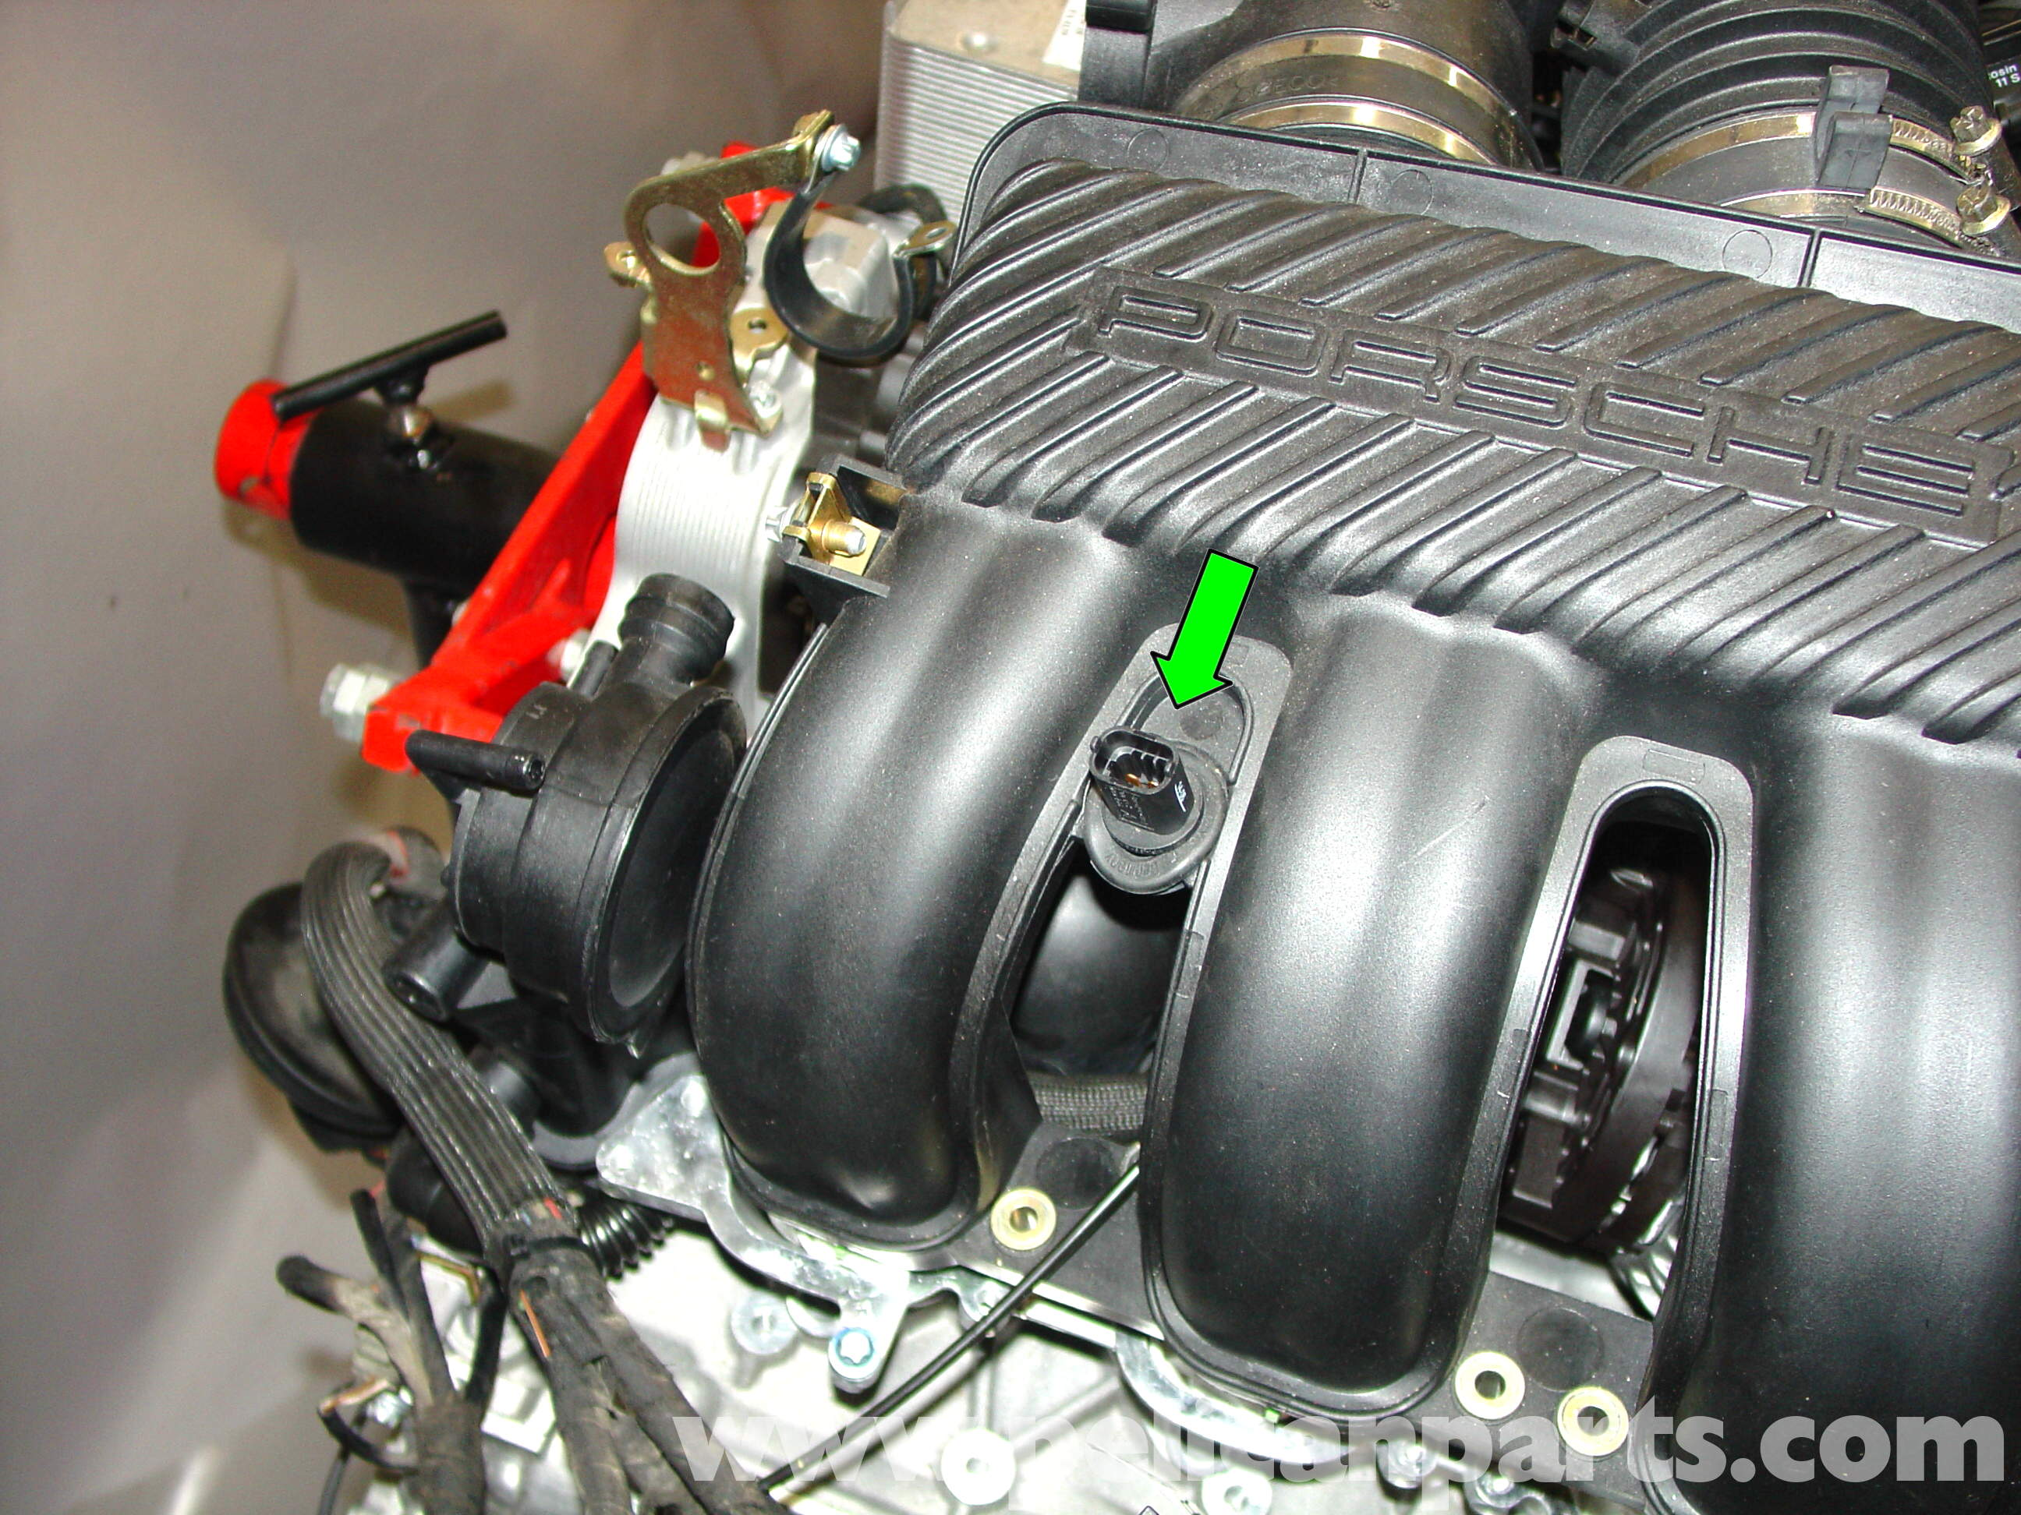

Coolant Temp Sensor - The coolant temperature sensor is located on the pulley side of the engine off to the right side of the car near the cylinder head. This sensor measures the temperature of the coolant and is used to adjust mixture levels as the engine begins to heat up to optimum operating temperature.
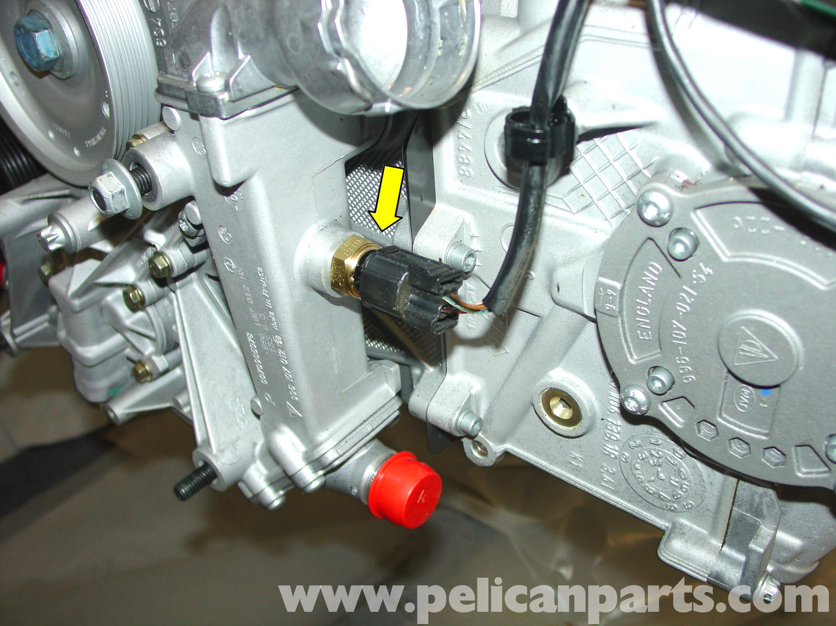

Oil Level & Oil Temp Combo Sensor - The oil level sensor/oil temperature sensor is shown by the blue arrow. This is a somewhat unique sensor in that it contains both level and temperature sensing functions within a single unit. Beginning in 2006 Porsche moved the Air Oil Seperator to this location and moved the oil level/temperature sensor to the left side between the starter motor and air pump. The knock sensors (purple arrow) have remained in the same locations. There is one installed on both the left and right side of the engine block. Located under the intake manifold, both of these sensors are relatively difficult to get to (you need to remove the intake tubes to access them
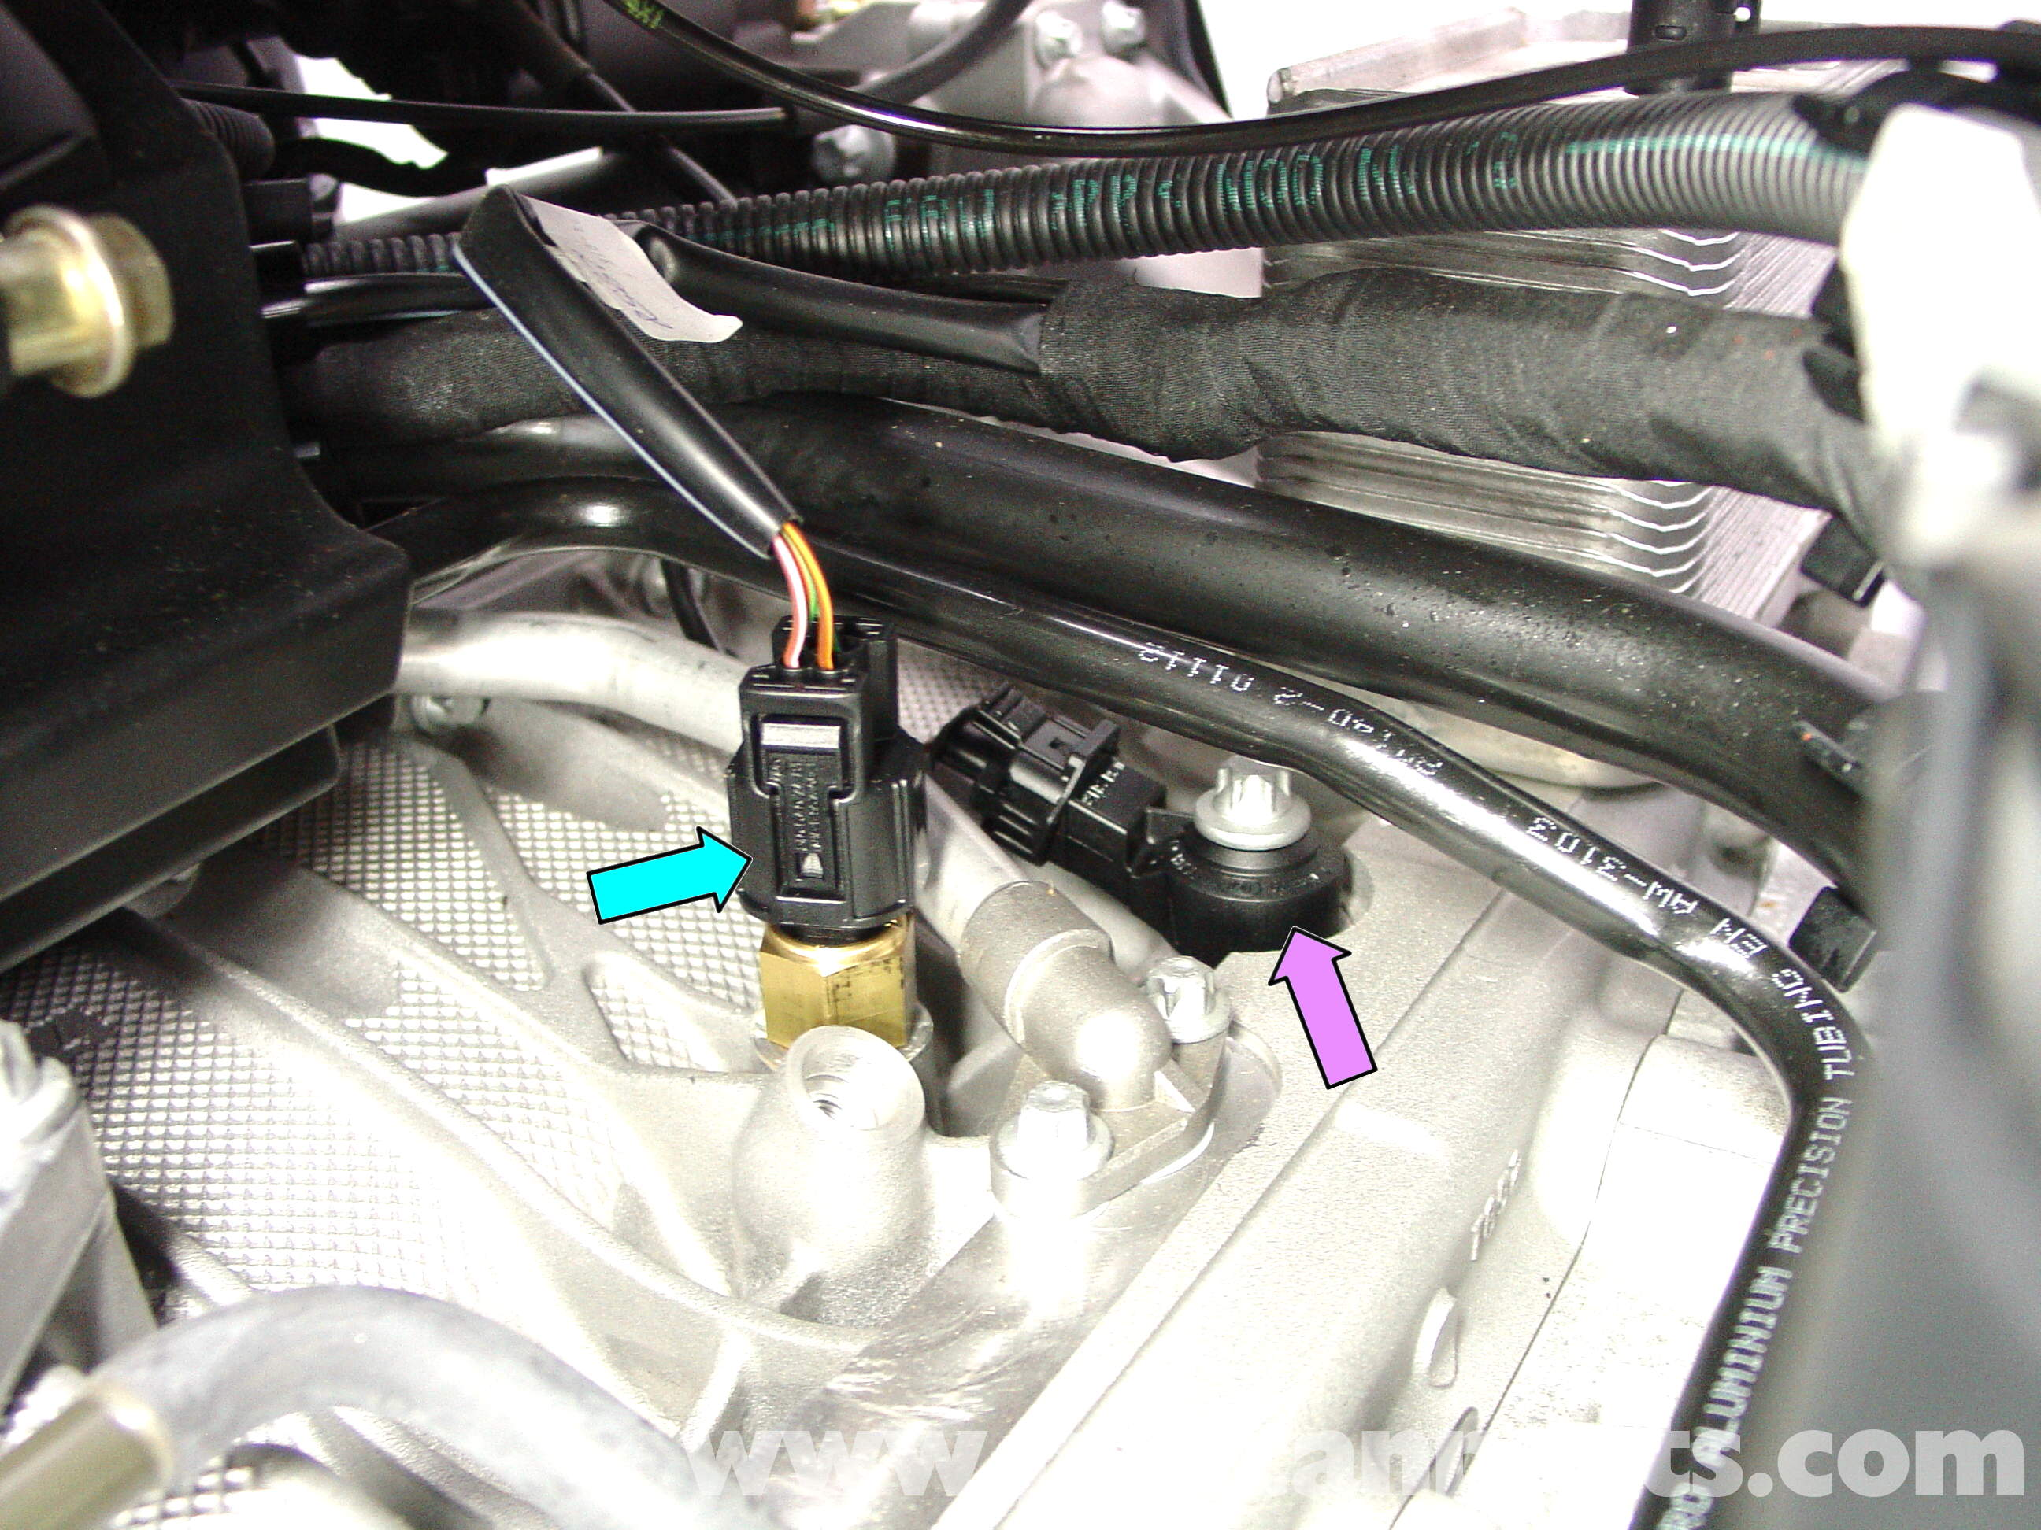

Crank Angle Sensor & Camshaft Timing Solenoid - This photo shows the group of sensors located on the left front of the engine. The purple arrow shows the crank angle sensor, or flywheel sensor, which reads the toothed flywheel as it rotates past the sensor (harness plug shown by yellow arrow). The orange arrow shows the camshaft timing advance solenoid (red arrow is the connector). You can access the sensor/solenoid from underneath the car and the electrical connections from the engine compartment.
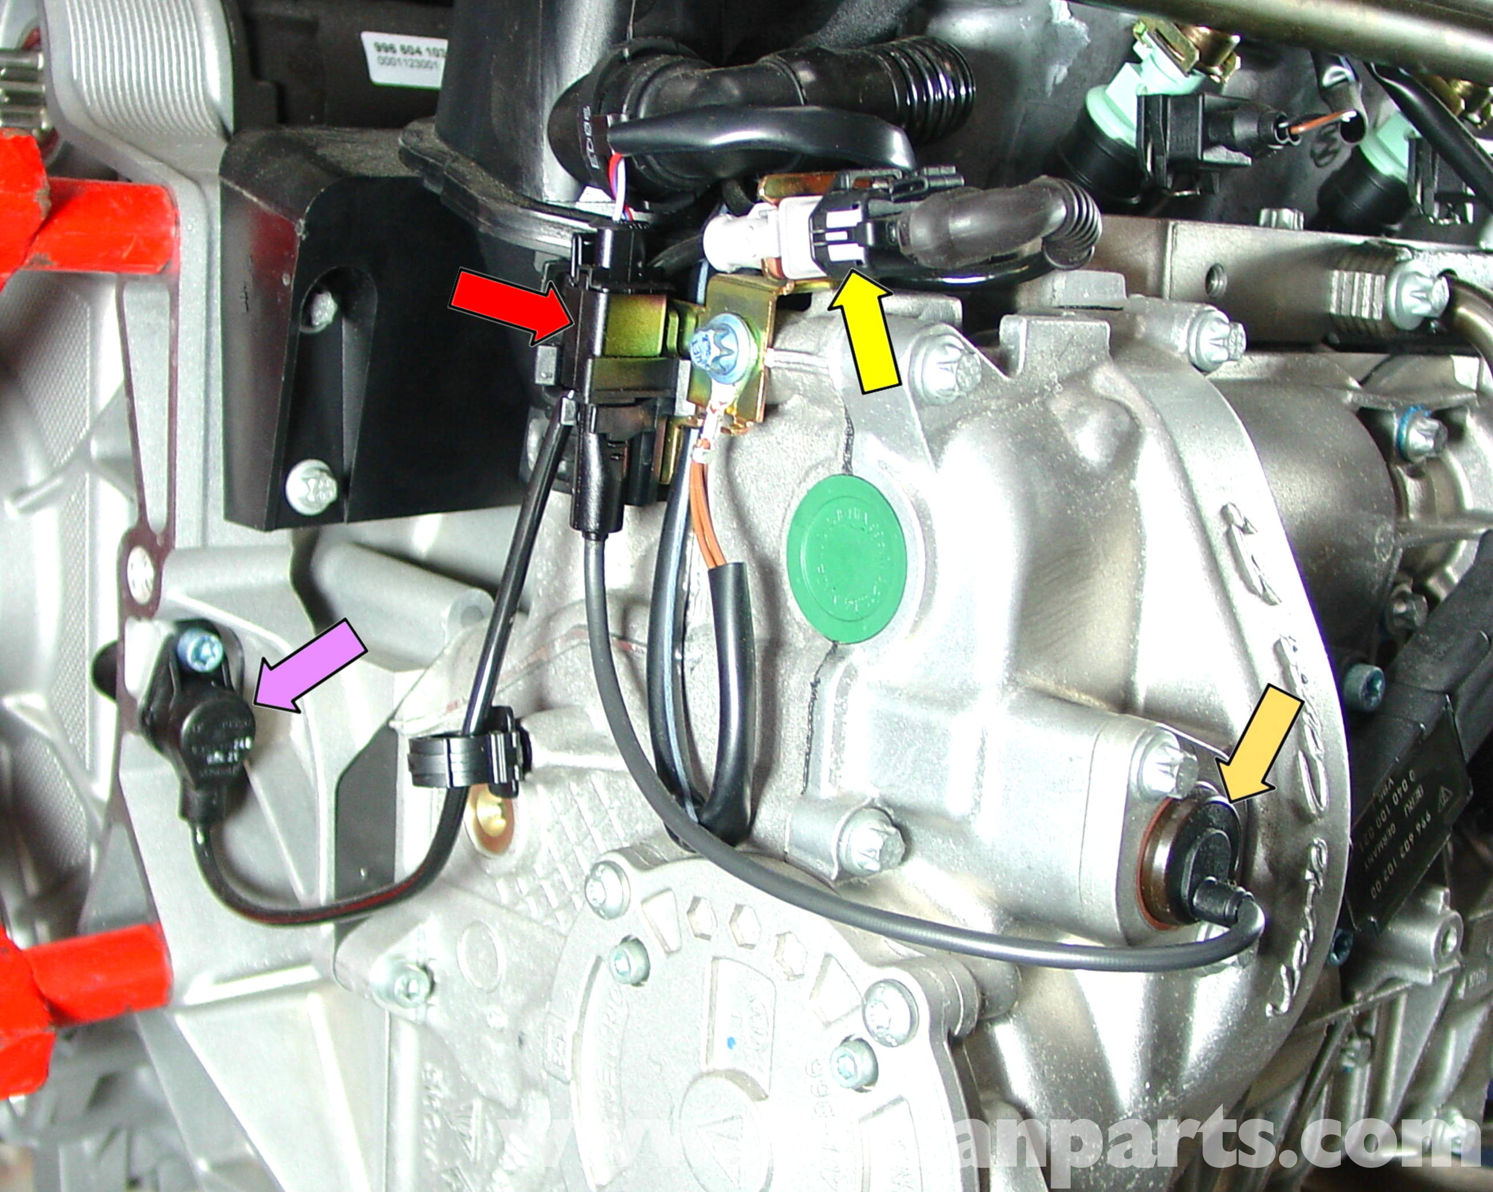

Camshaft Position Sensor - Shown here is the camshaft position sensor. There is one located on the top of the right cylinder head toward the rear and one on the left cylinder head toward the front for the five-chain motors used up to about 2001. For 2002 and later three-chain motors, the sensor is located on the top of the right cylinder head toward the front and on the left cylinder head toward the rear (insert photo, blue arrow).
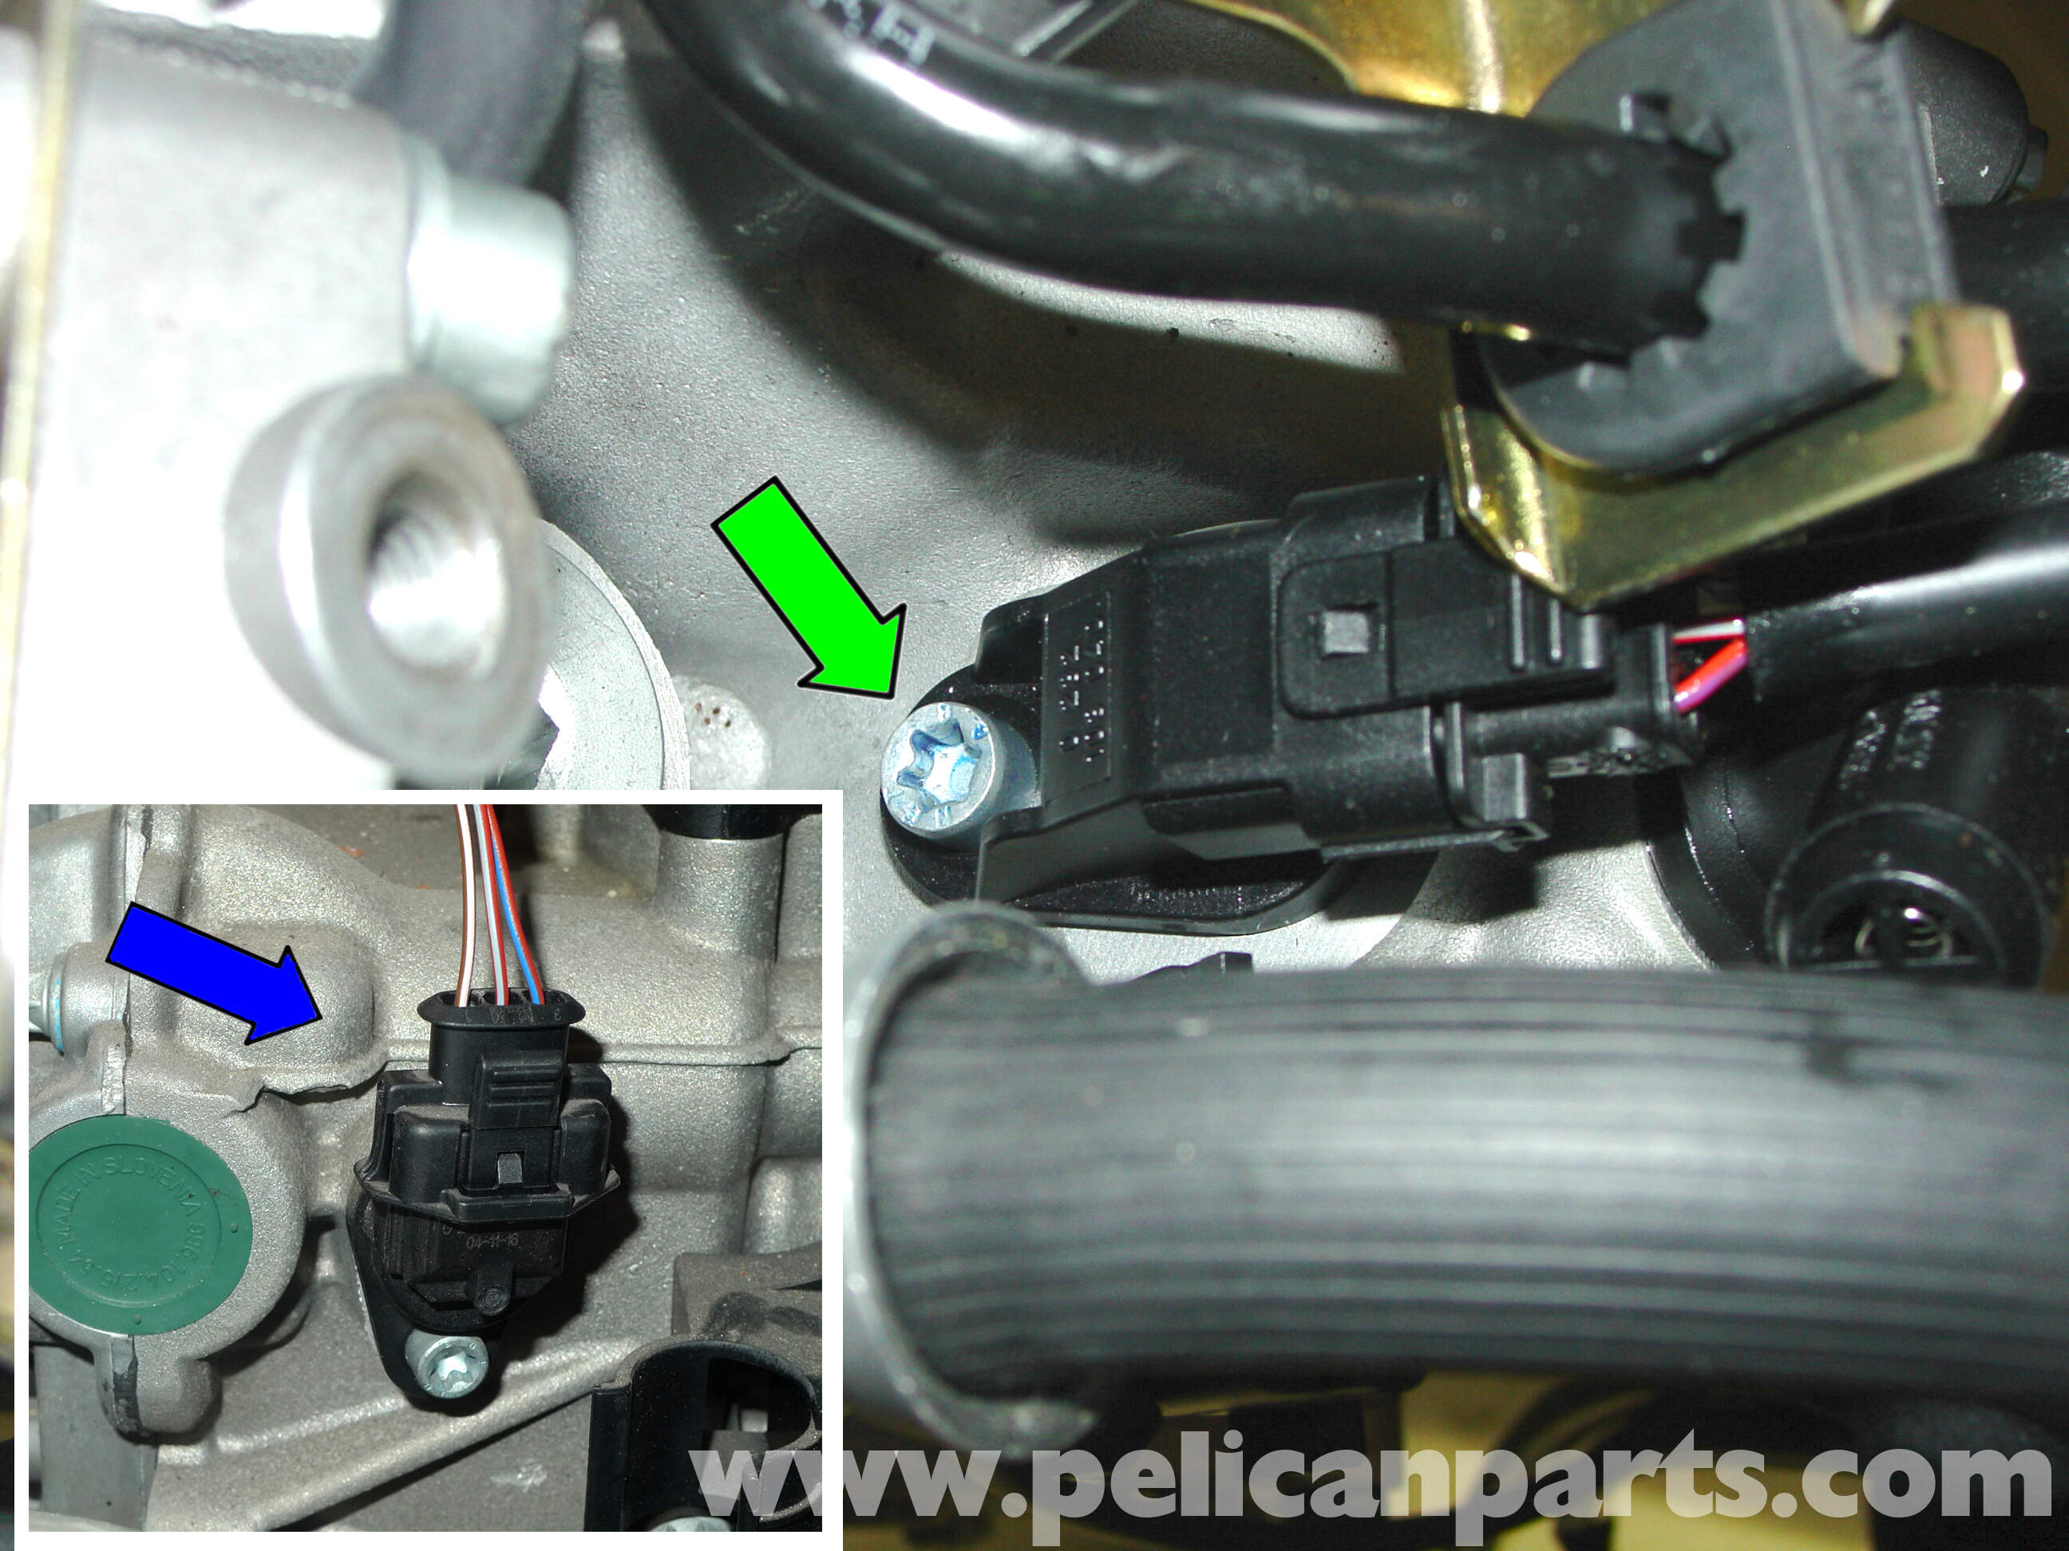

Oil Pressure Sender - This photo shows the oil pressure sender/switch. Located on the left-side cylinder head, this sender is a combination unit that senses pressure and also includes a low-pressure switch as well. Grab the sender by the base using a wrench--don't grab it by the canister, otherwise you may damage the unit and cause it to leak. Use new sealing rings to guard against oil leaks.
