90k major service done (oil, filters, belts, spark plugs, transmission oil and transmission mounts) on the car at a Porsche dealer. The next service is in about 7k miles at 105k miles, but this is only a minor service. Both the brake discs and the brake pads where changed at 85k miles, and there is still plenty of life left in them.
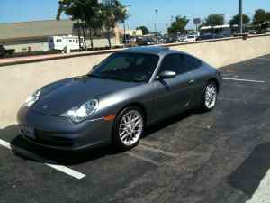 |  |  | 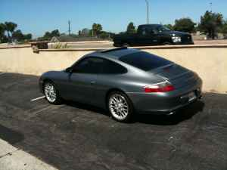
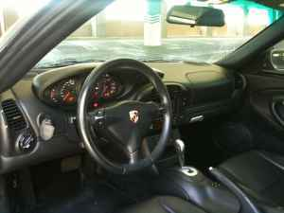 |  |  | 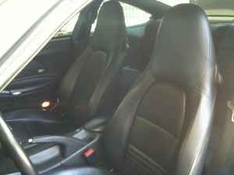
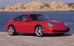2003 Porsche 911 Carrera Tiptronic 2dr Coupe
 |  | Trade-In |  | Private Party | Dealer Retail
 | National Base Price | $22,180 |  | $24,513 | $26,666
 | Optional Equipment | $1,070 |  | $1,187 | $1,438
 | Xenon High Intensity Discharge Headlights | $153 |  | $170 | $206
 | Stability Control | $159 |  | $177 | $214
 | 18 Inch Alloy Wheels | $758 |  | $840 | $1,018
 | Color Adjustment  Gray | $104 |  | $115 | $125
 | Regional Adjustment  for Zip Code 90404 | $48 |  | $53 | $57
 | Mileage Adjustment  100,000 miles | $-1,705 |  | $-1,705 | $-1,705
 | Condition Adjustment  Clean | $0 |  | $0 | $0
 | Total | $21,697 |  | $24,163 | $26,581

