Yes, it is a good preventative measure, but just make sure it is the right valve they replace. There are two valves, one is a check valve, one is a one way SAI valve. The check valve is upstream of the one way valve to prevent the air bump getting destroyed when the one way SAI valve fails. The SAI valve is the one that should be replaced on a regular basis.
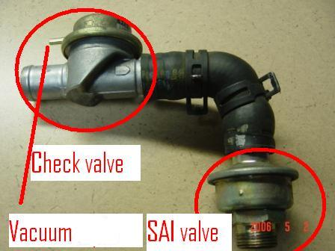
__________________
Robin
Rennlist Lifetime Member 990415-1116
Rennlist 2nd Member 020204-3360
Rennlist 3rd Member 020215-3380
(Help support Rennlist, you can have more than one membership)
96 993DX (2 wheel drive Carrera Coupe)
99 996DX4 (4 wheel drive Carrera Coupe)
00 BMW 328i
http://www.p-car.com

