I've worked up a couple of graphs to show how to replace selected resistors to change the speed at which the spoiler extends/retracts.
The 39K ohm resistor (orange-white-orange) boxed in black in the pic below can be replaced with another resistor with a value that corresponds off of the graph labeled "39K ohm Replacement". The speed at which the spoiler retracts remains the same, but the speed at which it extends is changed.
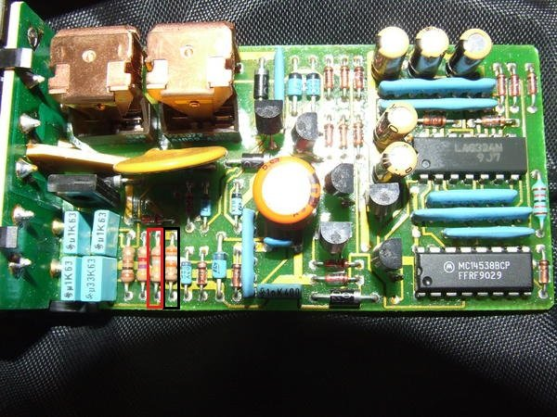
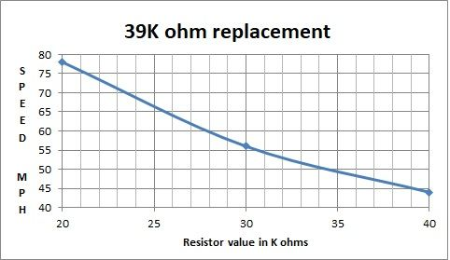
The 180K ohm resistor (brown-grey-yellow) next to the 39K will change the speed at which the spoiler extends and retracts as shown in the below graph.
