1st Annual 3rd Coast Spring Fling
Hosted by: Tony & Tambra
Sponsored by: 928sRUS & 928 Owners Club
Fri, Mar 25: Check in: www.lighthousetexas.com Safe, lit, free parking. 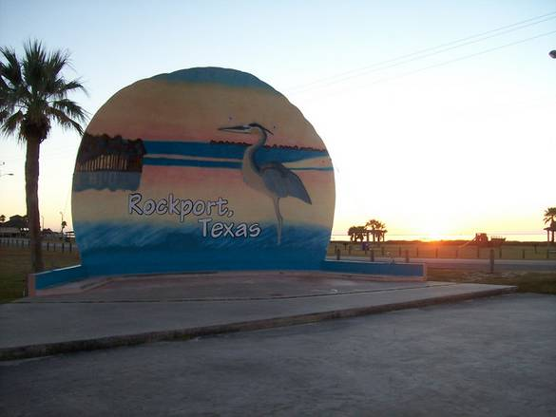
Dinner: 7:00: Park 928’s next door at: www.cherylsbythebay.com 928 OC Banner will be up and will have dedicated parking for the 928’s. No need to worry about DUI’s, just leave 928’s in front of Cheryl’s & stumble 100’ back to Hotel, or drive 100’ back to hotel if you prefer.
Sat, Mar 26th 9:30: Breakfast included at The Lighthouse Inn. Then it’s onto Adam’s Automotive for tech session. Corner of Bus 35 & E Concho-3.4 miles south. Tambra will pick up gals at Hotel in our 7 passenger Wagon and transport to Austin Street for some shopping and then lunch at “The Beach House”. Tony will BBQ your free lunch at Adam’s Automotive during tech session. Dinner: 7:00 Across street from hotel at: www.boilingpotonline.com
Sun, Mar 27th 9:30am- Breakfast included at The Lighthouse Inn. 11:00 follow T&T to Goliad,(66 miles North) a cool little TX Town for lunch & photo ops. After lunch, drive 26 miles West to: www.texasmile.net Watch some great racing & head back home at your leisure. See ya’all in the Fall at the 11th Annual 3rd Coast Fall Event, Marble Falls, TX. T&T

