Procedure for converting 86 944 AC from R12 to R134 A. part 2

This document describes the decisions, tools, and procedures I used to change my 944 to R134A. I’ve used a similar approach on a Lincoln Mk VII- obviously modified for the different hardware. The 944 was converted 4 weeks ago and cools very well. The Mk VII also works well.

The procedure is not hard but it is complex. Hopefully this will highlight key decision points and details.

The gauges and valves. Below is a simplified schematic. Looks complex but it’s really not bad.

Yellow/orange tap into the manifold. This is always open to the center fill tap. The left “blue” knob opens/closes the low pressure Schrader and gauge to the manifold. The right “red” knob opens/closes the high pressure Schrader and gauge to the manifold.

The high pressure valve is used once to purge the high side line. Otherwise it must remain closed. The high pressure will burst the Freon can.

The side or front Schraders are used to bleed the manifold before you start charging. Other than that, they won’t be used.

“Fake” Schrader for storing hose- ignore

Pulling a vacuum.

Unfortunately, the way I converted my gauges makes this more complex. No worries though, it works fine. I “beheaded” the yellow center hose and attached the 134a fill connector. The vacuum pump uses the older fitting and won’t connect to the yellow hose. The solution? Move the red hose to the center during vacuum work. See below:
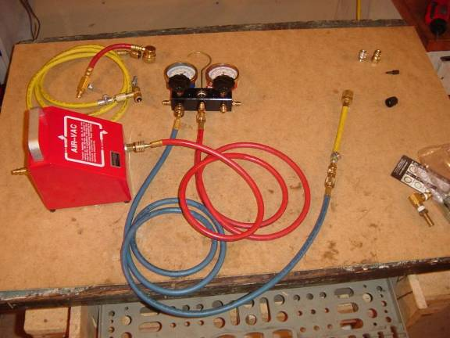

The high pressure gauge connection is free. The 134a high pressure adapter and yellow center hose are not used. Connect the red hose from the vacuum pump front connector to the center manifold fitting. On the back of the vacuum pump, you can see a quick connect that attaches to your air compressor.

To pull vacuum attach the low pressure hose to the car, the red hose as shown, and the vacuum pump to your compressor. Once the compressor is pushing air through the venturi, open the low pressure valve. This is really loud. Give the system about 15-30 minutes of vacuum. After that, first close the low side gauge valve then turn off your compressor. If you don’t close the valve first, air will such back into the system.

Leave the low gauge attached, valve off for 15-30 minutes. If the system holds vacuum, you are golden. If not, consider finding the leak.
System Fill Prep:

Get a coffee can or something that size and fill it with hot water. Keeping the Freon can in the hot water will speed up filling. As you fill, the Freon in the car gets hotter and the can gets colder. Soon the can’s vapor pressure can’t push Freon into the system. Shaking the can in hot water keeps things flowing.

Move the red hose back to the high side, install the yellow middle hose. If you have the high side port installed, attach the high side adapter. Notice this adapter has a valve:

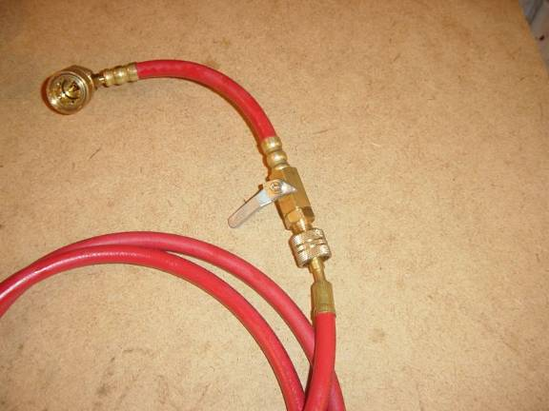

When you are done, this hose will be full of liquid 134a at high pressure. Close this valve (it is shown closed) before your remove the hose from the car. Take the gauges outside and open this valve a bit to discharge the 134. There is a lot in there. If you let it out fast, you get an ice crystal cloud- kinda cool really. If you didn’t convert the high valve, make sure you have the red hose installed with the “valve” end towards the car. This end has a little nub that presses the high side Schrader. It also has a one way valve that will close when you take it off.

Tap the oil fill can first. Screw the valve on the tap all the way out (CCW) then screw the tap onto the can. If not attached to the yellow hose, do so now. Turn the valve tap clockwise until it pierces the can. Give it a few more turns to make the hole bigger.

At this point, you should have:

All valves including can tap closed

Blue hose with yellow adapter attached to low pressure side.

Red hose with or without adapter attached to high side. Note- inline valve on adapter should still be closed

Yellow hose and can tap to 134a plus oil.

Hot water

Car not running, AC system still under vacuum (if some air got in when you attached the high side, it’s OK).

Filling:

Purge manifold and low pressure side:
Before you fill, purge the manifold by opening the can tap valve, holding the can upright, and pressing one of the free Schrader manifold valves. It doesn’t take too long- you will smell the 134a.

Use one of the green schraders to purge.

Oil fill (if using pressurized oil)
If you are filling with pressurized oil, lift the can above the gauges and invert it. You need to “liquid fill” the oil- inverting the can pushes the liquid (oil in this case) out first. Once the oil is in, keep the rest of the can upright for “vapour fill.” If you liquid fill while the compressor is running, it could liquid lock and break. You should be able to tell when the oil is in- the can will be a lot lighter. Once the oil is in, spin the compressor a few times by hand to make sure it isn’t liquid locked. Put the can in the hot water and let it continue to fill until you can’t here it flowing.

Open Low side valve (Blue circle) and oil/Freon will flow from middle tap (green arrow) past site glass (pink dot) and into AC low side valve (blue Schrader).

Purging Hiqh side.
At this point, you need to purge the high pressure line. Close the low pressure gauge valve and can tap. Open the inline high pressure valve. The high side gauge should now read the same as the low (it will look different because the scales aren’t the same). Open the high side gauge valve. Use one of the free manifold Schraders to purge the air.

Low side (blue), can tap closed
Open inline valve (pink on red)
Open high side valve (red circle)
Use one of green Schraders to purge.

Close High side manifold valve and leave closed until you disconnect from car.

Filling
Verify high side manifold valve is closed. Open low side valve. Open can tap. At this point, both gauges should read the 134a vapour pressure- around 70 to 80 psi depending on temp. Close low side valve.

Set your AC system to max cool, start your car and engage the A/C. The pump should start and pull the low side pressure down. Since the system is low, the pump will stop when the low pressure limit is reached- around 10-20 psi, I think. Shut off the car. If the pump didn’t turn, try to fix the problem. For filling, you can jumper to the AC clutch to the batter but be careful not to let it run below 10psi on the low gauge or for more than a minute at a time.

Restart the car, rev it up to 1500 rpm, and turn on the AC. Immerse the Freon can in hot water and open the low side valve. The running low side will go up to around 50-70 psi as it fills. If the pump shuts off, you may want to close the low side valve so you don’t get back flow. After a while, the max running low side pressure will start dropping, indicating that the Freon can is running out. Once flow stops or is real slow, shut off the low side valve, pull the Freon can out of the hot water, and purge the manifold to empty the can. Replace the Freon can- remember to back the pierce valve all the way out first.

If you are using a booster, that should be added after the oil. Some boosters have oil in them- you may want to do a small oil charge, the oil/booster, then regular Freon. Once the low side is always over 20 and the high side approaches 250 psi max, you are done. There should still be some bubbles visible in the drier sight glass. The vent outlet temp should be under 50 degrees. My car had a high pressure cutout at 250 psi so I had to play with the pressures to get decent cooling without the pump shutting off due to high pressure. If I was a perfectionist, I could have put a 134a high pressure switch in- I think they are set at around 300 psi.

When done, close all valves including the high side inline valve, disconnect, and enjoy. Once a Freon can is pierced, it can’t be resealed so leave it on the tap with all the valves closed.

Have fun.

Extra info:

My 944’s Nippondenso lists low viscosity PAG oil as correct. This is available in small cans like brake fluid. You need to pour it in while the system is open. Ester “universal” conversion oil can be found mixed with 134. This allows you to feed it into a closed system under pressure. This is much easier and, if I did it again, I’d used Ester.
My 944 had enough R12 to run but not enough to cool effectively. Overall, the system seemed in good shape. I took the car to an AC shop and asked them to check it over and, if it was slightly low, just top it off. However, if it needed work or a significant amount of R12, I asked them to evacuate the system so I could convert it.

If you want your car converted professionally, Dealer Services in Hopkins is the consensus choice as the best in town. Expect to pay around $500.

There are a lot of horror stories about home conversions. When 134A was first introduced, the oil used would react with any residual mineral oil in your system, form an acid, and eat your compressor. Nowadays both PAG and Ester oils play nice with mineral oil. Still, you should try to remove as much of the old oil you can since it just sits around and takes up space.

Other common “myths:”

1. You need to replace your hoses- technically true- the 134a molecule is smaller than R12 and, over time, small amounts diffuse through the hoses. New hoses hold 134a. For my car, a set of hoses was around $300 while WalMart sells 12 ounces of 134a for 8 bucks. I can buy a lot of cans for the price of new hoses. If you are brave, the hose is cheap and can be crimped onto your present hose ends. However, the crimping process has little room for error- too loose and they leak, too tight and you rupture the barrier layer and they leak. The cheapest crimper I found was around $125.

- You need to replace the condenser and expansion valve or your system won’t cool- Again, base on fact but not carved in stone. For a given system size, a 134a system needs more condenser function (the big radiator in front of your water radiator) than an R12 system. However, most systems are overdesigned so the need is exaggerated. If you are converting a Yugo or Ford Festiva, you may need to buy a newer style condenser but both the 944 and Mk VII were fine. Same with the expansion/cvot valve- one optimized for 134a will help but most cars are fine.

- You need to replace the pressure switches- again, technically true and, in some cases, a legal requirement. Because 134a runs at slightly higher peak pressures, you system needs to include a high pressure safety switch. My 944 has one already as did, I believe, the Mk VII. If your car doesn’t, switches are cheap and most cars have a port available for installation. On the 944, the existing HP switch activation switch is a bit too low so I get more pump cycling but it cools fine.

- You need to replace all O-rings- some very old systems use O-rings that will melt in the new oil. Most cars are fine. However, if you split a connection, you need to replace the O-ring. Dip the new O-ring in the new oil before you install it.

- You need to replace the pump- I don’t buy this. Again, maybe the really old pumps won’t work but anything after the early 80’s should be fine. Even if it fails, you aren’t out much so it is probably worth the risk to give the old pump a shot.

On to things that you probably should do.

Replace the receiver dryer (or accumulator)- these contain a dessicant. Some older dessicants melt in 134a. I bought a new dryer for my car at Bumper to Bumper for 35 buck including new o-rings. Cheap insurance.

Buy/borrow, get from the library a book on AC, hopefully specific to your car or conversion. It never hurts to study. At a minimum, it will tell you the amount of oil you need. I found the official Porsche conversion tech note on the internet.

Use “Freon Booster.” I have no data but I used a can of booster in my 944. I also added some to our ’94 Accord. The Accord AC is a first year 134a factory system and has always been marginal. The booster seemed to help. Cans range from about 20 to around 40 bucks or 2-4 time the cost of 134a. I used the cheaper booster and, as I said, it seems to help.

