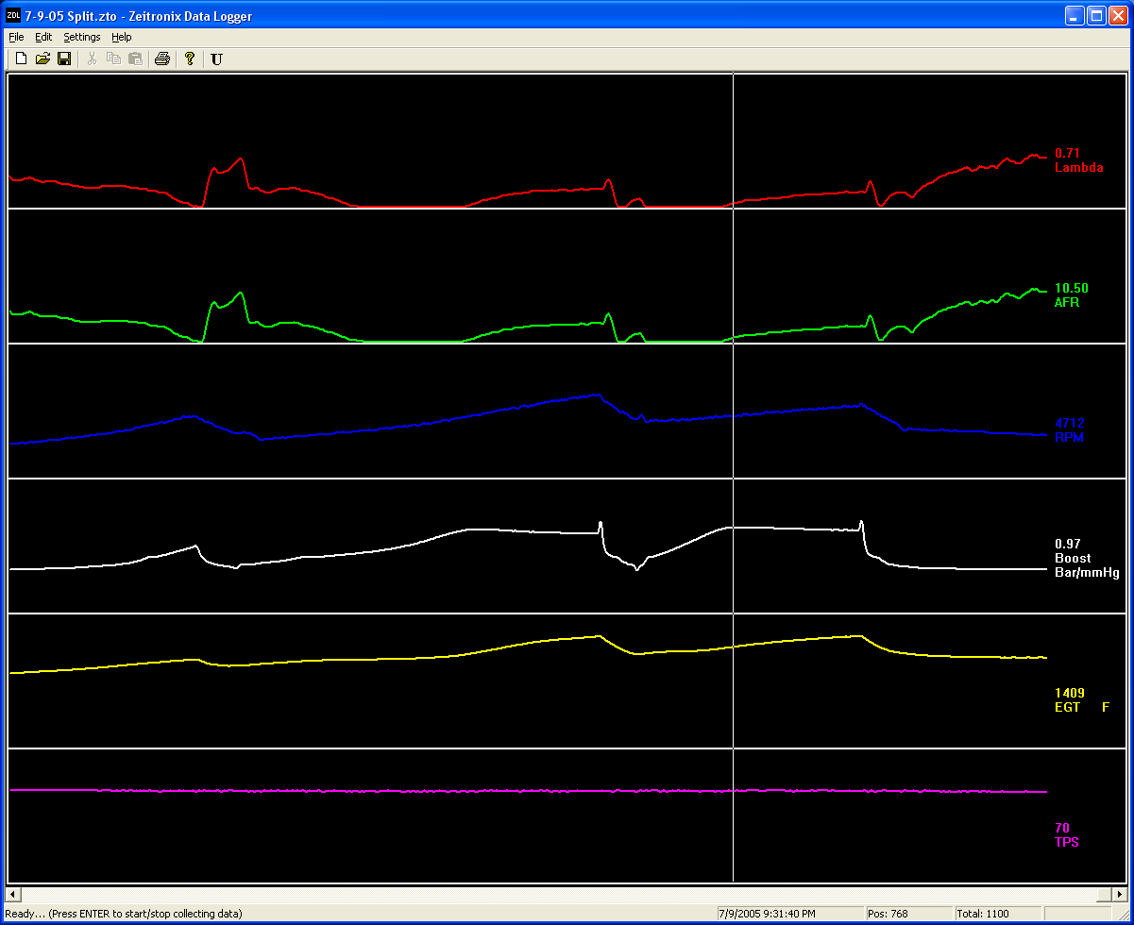

Max Boost = 0.97 BAR (Third Gear WOT)
That’s over a sea level atmospheric pressure, actual gauge pressure of 1.2 BAR at my altitude of 6400 feet.
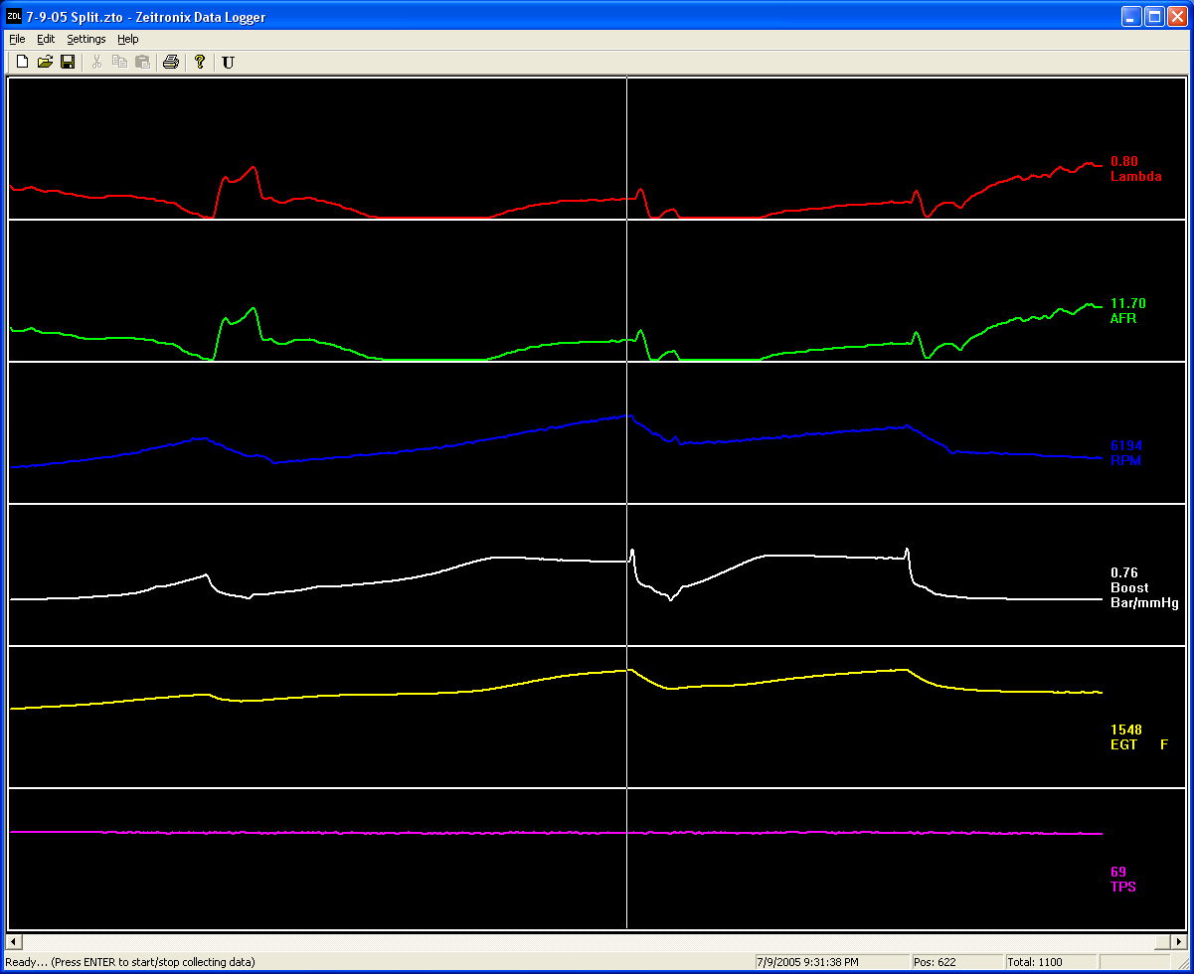

Max AFR = 11.70 (Second Gear WOT @ 6200 RPM)

