I can’t vouch for these pictures but if they are real they are horrible.
Rudy Yarbrough

From: CAMACK6969@aol.com [mailto:CAMACK6969@aol.com]
Sent: Sunday, June 28, 2009 1:21 PM
To: za071@hotmail.com; Bill_Bailey@URSCorp.com; barc30@clearwire.net; muleteam@summergrove.net; mffalcon@cox.net; davehallman@bellsouth.net; dk5x55@bellsouth.net; team88race@bellsouth.net; smargrey@bellsouth.net; hiflyte@cfl.rr.com; jsmith1151@ellijay.com; rstewart@troy.edu; jonedy@bellsouth.net; mctint@att.net; georgefranklinthompson@comcast.net; yarbros@comcast.net
Subject: Fwd: Unbelieveable photos from inside Air France plane

WOW

From: TRUSSELL10
To: wjbritt60@yahoo.com, gm58@juno.com, mgondron@cfl.rr.com, hiflyte@cfl.rr.com, dennisnurre@bellsouth.net, CAMACK6969, jonedy@bellsouth.net, Les6740, s.tennant@nasig.com, Heatonair245, lsbortnem@verizon.net, hspeercpa@yahoo.com, garyw1862@embark.com, jburch024, rayrealtor1@yahoo.com, wwhitley5@cox.net, ecwhit@msn.com, kellypave@yahoo.com, kwilterdink@yahoo.com, johnrussell45@msn.com
Sent: 6/28/2009 12:10:20 Eastern Daylight Time
Subj: Fwd: Unbelieveable photos from inside Air France plane

Make your summer sizzle with fast and easy recipes for the grill.
-----------------
Forwarded Message:
Subj: | Fwd: Unbelieveable photos from inside Air France plane
Date: | 6/27/2009 18:09:02 Eastern Daylight Time
From: | RHBhansen
To: | Rodrider123, TRUSSELL10, chrisbrightideas@bellsouth.net, up4golf@bellsouth.net, hrooseveltcvn71@msn.com, hansenhanny@msn.com, jcarp@hickorytech.net, blpurdy@mchsi.com, jcbraun@core.com, jscheuer33@mchsi.com, Snotfu47@yahoo.com, bkiger@yadtel.net, rbslodysko@yahoo.com, dennis.marra@tycofp.com, jeffswave@msn.com, rdenson@cfl.rr.com, cristalswave@live.com, tedkolby@cfl.rr.com, Rigasaurusrex@earthlink.net, Ccdc98, fathucker@hotmail.com

-----Original Message-----
From: Bill Bunka <billbunka@gmail.com>
To: Bucky and Dee Hough <flhough@gmail.com>
Sent: Sat, Jun 27, 2009 9:24 am
Subject: Fwd: FW: Unbelieveable photos from inside Air France plane

<billbunka@gmail.com>, BOBBI G <bobbie227@aol.com>, BOBBY E <johnn40@comcast.net>, CYNTHIA C <knicksfan36@hotmail.com>, DAVE <seaandde@bellsouth.net>, DI MARKS <dmmarks1@bellsouth.net>, EDDIE G <edward_grassi@yahoo.com>, FRAN Z <grand.mama@verizon.net>, H S <pokerbaby6@aol.com>, KATHY H <khollis2@wi.rr.com>, LIZ <lizgaeta@optonline.net>, LORETTA S <loretta123@hvc.rr.com>, MARGE <mmcorso@msn.com>, robert_t_owen@yahoo.co.uk, WALTER <wschlehno@bellsouth.net>

From: bwacik7002@bellsouth.net
To: BWACIK7002@MSN.COM; LC4321@YAHOO.COM
Subject: Fwd: Fw: Unbelieveable photos from inside Air France plane
Date: Sat, 27 Jun 2009 11:18:01 +0000

-------------- Forwarded Message: --------------
From: Ez185s@aol.com
To: Marsbar117@hotmail.com, bwacik7002@bellsouth.net, FOXY1935@aol.com, cdoby1@comcast.net, Jwmassey6@peoplepc.com, Magiclee.Dave@gmail.com, Jerrybgrd2@yahoo.com
Subject: Fwd: Fw: Unbelieveable photos from inside Air France plane
Date: Sat, 27 Jun 2009 04:36:22 +0000

Make your summer sizzle with fast and easy recipes for the grill.
--Forwarded Message Attachment--
From: salem519@bellsouth.net
To: Ez185s@aol.com; takacs@cot.net; mamamusella40@yahoo.com; jmcgovern1@bellsouth.net; jim8e3@tds.net; ftruff@comcast.net; fmirabito@aol.com; honeyskl16@hotmail.com
Subject: Fw: Unbelieveable photos from inside Air France plane
Date: Fri, 26 Jun 2009 13:56:12 -0500

----- Original Message -----
From: Barbara Miloscia
To: Kristen Billings ; eric billings ; Roe & Dennis Birmingham ; Sal & Emily Musella ; peggy morgello ; luca deangelis ; mary miller ; marie gannascoli ; carol amole ; sylvia lopiccolo ; leslie floyd ; tina carlucci ; carolyn cattania ; Karen Pepp
Sent: Thursday, June 25, 2009 4:56 AM
Subject: Fw: Unbelieveable photos from inside Air France plane

Subject: Fw: Unbelieveable photos from inside Air France plane

The two photos attached were taken by one of the passengers before the aircraft crashed. The photos were retrieved from the camera's memory stick. You will never get to see photos like this. In the first photo, there is a gaping hole in the fuselage through which you can see the tail plane and vertical fin of the aircraft. In the second photo, one of the passengers is being sucked out of the gaping hole.

These photos were found in a digital Casio Z750, amidst the remains. Although the camera was destroyed, the Memory Stick was recovered. Investigating the serial number of the camera, the owner was identified as Paulo G. Muller, an actor of a theatre for children known in the outskirts of Porto Alegre . It can be imagined that he was standing during the turbulence, he managed to take these photos, just seconds after the tail loss the aircraft plunged. The structural stress probably ripped the engines away, diminishing the falling speed, protecting the electronic equipment but not unfortunately the victims. Paulo Muller leaves behind two daughters, Bruna and Beatriz.

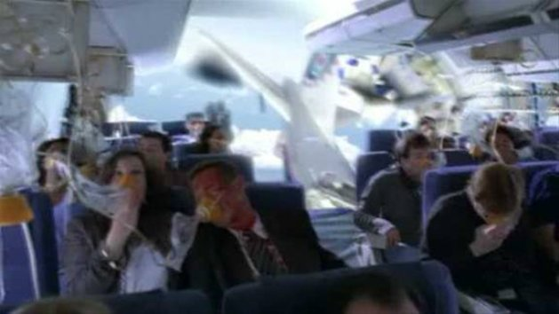

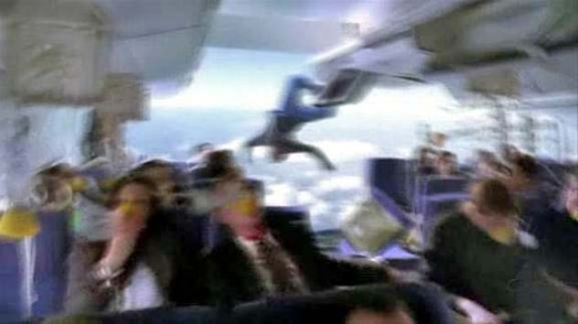

--

Save energy, paper and money -- get the Green Toolbar.

An Excellent Credit Score is 750. See Yours in Just 2 Easy Steps!

