VISUAL HEADLIGHT AIMING PROCEDURE

INTRODUCTION: It is of utmost importance that your vehicle's lighting system be aimed properly in order for it to perform its best. Lights that are aimed incorrectly will not only perform poorly but may also offend oncoming traffic.When replacing capsules, it is a good idea to verify that your lights are properly aimed. Slight variances in filament position can translate to large variances in beam pattern. The following procedure does not require special aiming equipment and ensures proper aim.

STEP 1: Find a flat level surface adjacent to a vertical white wall where the car can be parked (a garage door is an ideal location at home). Pull the car straight up to the wall as close as possible and draw a vertical line on the wall corresponding to the centerline of the vehicle (this can be done most precisely by using a yardstick and extending it from the hood ornament or badge to the wall). Pull the car straight back until the headlights are 25 feet from the wall.
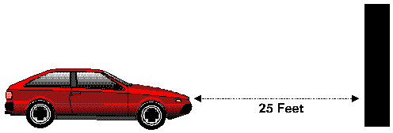
STEP 2: Make the following two measurements:
Measurement A: From the ground to the geometric center of one of the headlight lenses
Measurement B: From one of the low beam headlights to the vehicle centerline.
(Also measure from high beam center to vehicle centerline for 4 headlight systems)
Note these measurements.
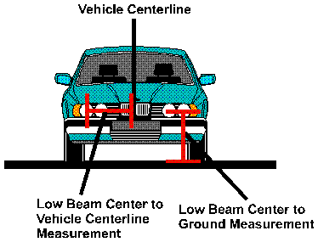
STEP3:
(A) Two Headlamp Systems:
Draw one horizontal line on the wall at a height exactly 2 inches lower than Measurement A made in Step 2. On the line, make vertical marks both to the right and left of the vehicle centerline mark at the distance of Measurement B from the vehicle centerline vertical line.
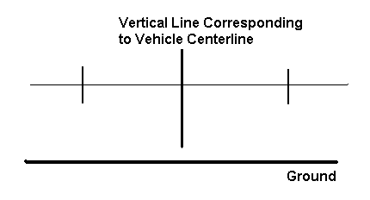

(B) Four Headlamp Systems:
Draw two horizontal lines on the wall, one at the height measured from the ground to center of the headlight and one at a height exactly 2 inches lower than the measurement from the ground to the geometric center of the headlight made in Step 2. Make vertical marks for the low beam on the lower line and vertical marks on the upper line for the high beam as in Part (A) above (the high beam marks are made at a distance corresponding to the high beam measurement made in Step 2).
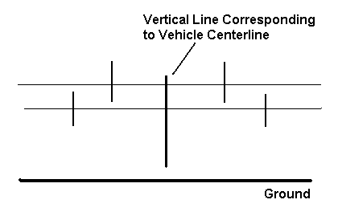
STEP4:
(A) Two Headlamp Systems:
Turn the headlights on and adjust the vertical aim of the headlights so that the top horizontal cutoff of each of the beams is located along the horizontal line drawn on the wall. Adjust the horizontal aim of the low beam headlights so that the point at which the top cutoff of the beam begins to slope upwards is located at the vertical marks made in Step 3 (A).
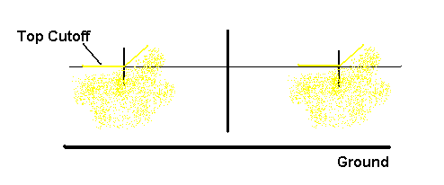
(B) Four Headlamp Systems:
Adjust the low beams as in (A) above. Adjust the high beams so that the center of the illuminated region is located at the cross formed by the upper horizontal line and the vertical marks made in Step 3 (B) above.